

**PCA 1**

**MAKAUT ODD SEMESTER 2024**

|  |  |
| --- | --- |
| **NAME:** | **RUPAK SARKAR** |
| **STREAM:** | **MCA** |
| **SEMESTER:** | **1ST** |
| **SUBJECT:** | **RELATIONAL DATABASE MANAGEMENT SYSTEM** |
| **SUBJECT** | **CODE: MCAN-192** |

**Q. CREATE THE TABLES WITH THE FOLLOWING SCHEMA:**

**SAILORS(SID, SNAME, RATING, AGE)**

**BOATS(BID, BNAME, COLOR)**

**RESERVES(SID, BID, DAY(DATE))**

Ans:

**SQL:** CREATE TABLE SAILORS(SID VARCHAR2(3) PRIMARY KEY, SNAME CHAR(20), RATING NUMBER(5), AGE NUMBER(5));

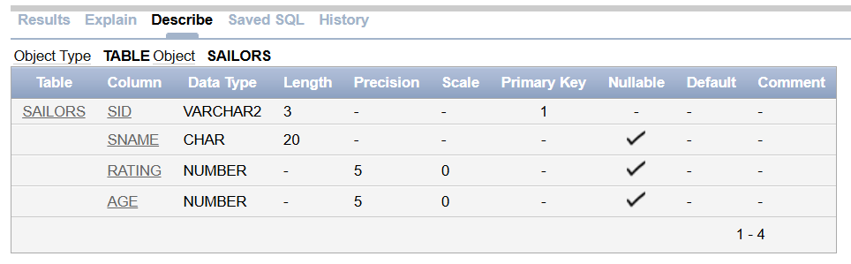

**SQL:** CREATE TABLE BOATS(BID VARCHAR2(3) PRIMARY KEY, BNAME CHAR(20), COLOR CHAR(10));

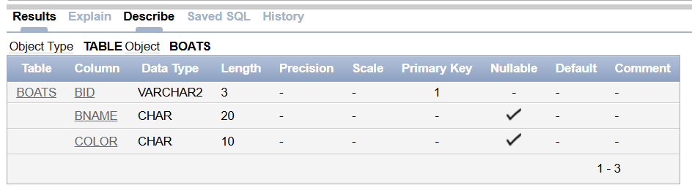

**SQL:** CREATE TABLE RESERVES(SID VARCHAR2(3), FOREIGN KEY(SID) REFERENCES SAILORS, BID VARCHAR2(3), FOREIGN KEY(BID) REFERENCES BOATS, DAY DATE);

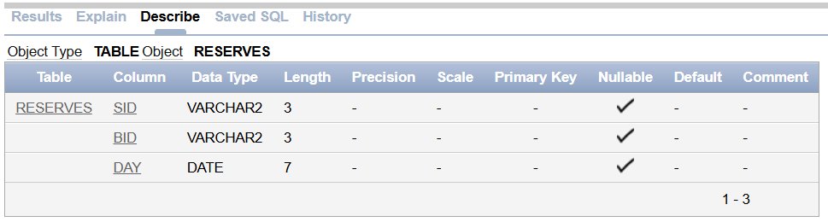

**VALUES OF THE TABLES:**

VALUE OF SAILORS TABLE:

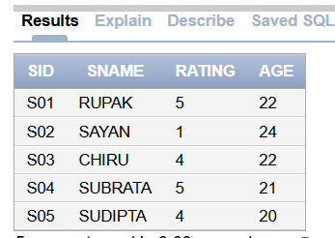

VALUE OF BOATS TABLE:

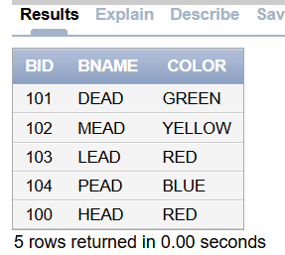

VALUES OF RESERVES TABLE:

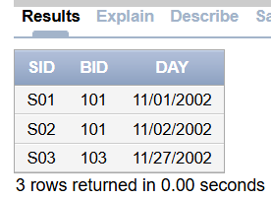

**Q.1. Find the information of all the sailors who have reserved boat reserved boat number 101.**

**SQL:** SELECT * FROM SAILORS S WHERE S.SID IN (SELECT R.SID FROM RESERVES R WHERE R.BID = 101);

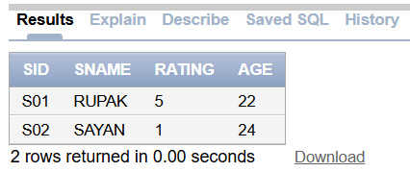

**Q.2. FIND THE NAME OF THE BOAT RESERVED BY BOB.**

**SQL:** SELECT B.BNAME FROM BOATS B WHERE B.BID IN (SELECT R.BID FROM RESERVES R WHERE R.SID = (SELECT S.SID FROM SAILORS S WHERE S.SNAME = 'BOB' ));

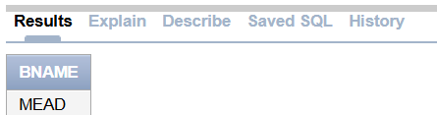

**Q.3. FIND THE NAME OF THE SAILORS WHO HAVE RESERVED THE RED BOAT, AND LIST IN THE ORDER OF AGE.**

**SQL:** SELECT S.SNAME FROM SAILORS S WHERE S.SID IN (SELECT R.SID FROM RESERVES R WHERE R.BID IN (SELECT B.BID FROM BOATS B WHERE B.COLOR = 'RED')) ORDER BY S.AGE;

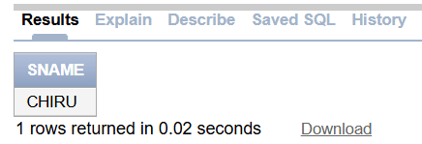

**Q.4. FIND THE NAMES OF SAILORS WHO HAVE RESERVED AT LEAST ONE BOAT.**

**SQL:** SELECT DISTINCT S.SNAME FROM Sailors S WHERE S.SID IN (SELECT R.SID FROM RESERVES R);

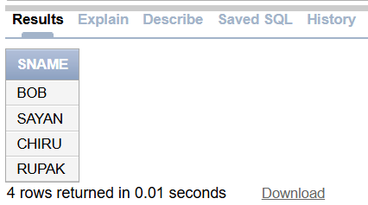

**Q.5. FIND THE IDS AND NAMES OF SAILORS WHO HAVE RESERVED TWO DIFFERENT BOATS ON THE SAME DAY.**

**SQL:** SELECT DISTINCT S.SID, S.SNAME FROM SAILORS S JOIN RESERVES R1 ON S.SID = R1.SID JOIN RESERVES R2 ON S.SID = R2.SID WHERE R1.DAY = R2.DAY AND R1.BID <> R2.BID;

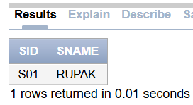

**Q.6. FIND THE IDS OF SAILORS WHO HAVE RESERVED A RED BOAT OR A GREEN BOAT.**

**SQL:** SELECT DISTINCT R.SID FROM RESERVES R WHERE R.BID IN (SELECT B.BID FROM BOATS B WHERE B.COLOR = 'RED' OR B.COLOR = 'GREEN');

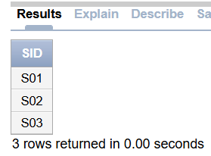

**Q.7. FIND THE NAME AND AGE OF THE YOUNGEST SAILOR.**

**SQL:** SELECT SNAME, AGE FROM SAILORS WHERE AGE = (SELECT MIN(AGE) FROM SAILORS);

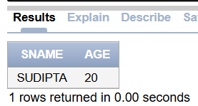

**Q.8. COUNT THE NUMBER OF DIFFERENT SAILOR NAMES.**

**SQL:** SELECT COUNT(DISTINCT SNAME) AS UNIQUE_NAMES FROM SAILORS;

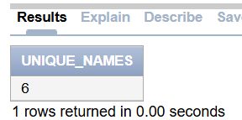

**Q.9. FIND THE AVERAGE AGE OF SAILORS FOR EACH RATING LEVEL.**

**SQL:** SELECT RATING, AVG(AGE) AS AVG_AGE FROM SAILORS GROUP BY RATING;

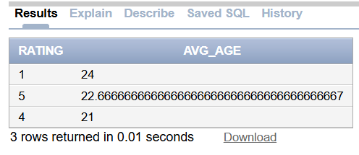

**Q.10. FIND THE AVERAGE AGE OF SAILORS FOR EACH RATING LEVEL THAT HAS AT LEAST TWO SAILORS.**

**SQL:** SELECT RATING, AVG(AGE) AS AVG_AGE FROM SAILORS GROUP BY RATING HAVING COUNT(*) >= 2;

